## Manual Modelling

Creating a scale 3D model of a room can be a fun and rewarding project. This article serves as a step-by-step guide to help you create a maquette for your Interior Design assignment.

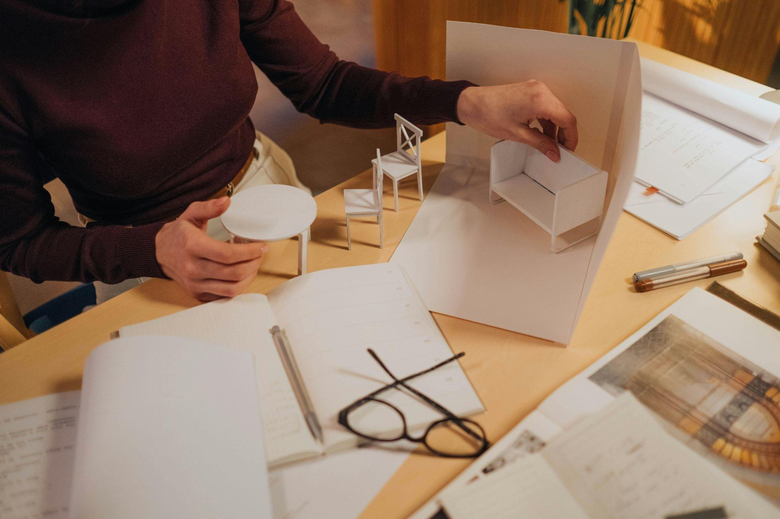

Fig. 1. Pexels (n.d.), Example of a model

There are a number of tools that can help you take a set of drawings from the page, and better visualise a space. Examples include 3D computer-generated models, maquettes (also known as scale models) and sketches.

## **Scale models**

Let’s start by understanding what a maquette or model actually means in Interior Design. A **maquette** or **scale model** in interior design is a physical representation of a space that has been created on a much smaller scale. It is used to visualise, plan, and communicate the layout, design, and overall aesthetics of an interior space before the full-scale project is executed.

Before you start to make a model, you need to decide on the scale you will use. Although 1:50 is appropriate for an entire house, and 1:20 is suitable for a single room. It is also important to make sure you have decided how much detail you will be adding to your model. Models made on a smaller scale often mean that details such as furniture may have to be omitted.

Once you have decided the scale you will be working with, you will then produce Technical Drawings at that scale. These will serve as the pattern (i.e. the scaled floor plan and elevations) for your model. Scale models can be a very useful way to animate a design and give the client a better idea of the final result. While making a scale model can be time-consuming, it can also help to give you a better understanding of the design space, including proportion and structural details. It also allows you to easily experiment with different finishes and furniture.

Scale models can be produced using a variety of different materials, and texture and pattern can also be transferred through photographs or painted on paper. There is no limit to the materials you can use to produce your scale models. Below are some examples of scale models made up of different materials.

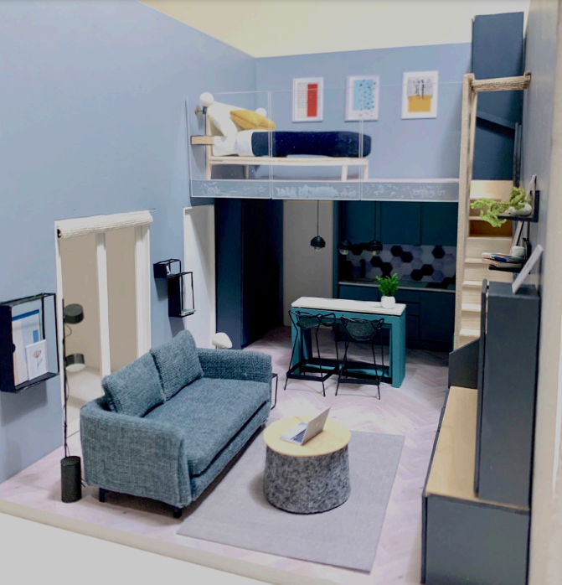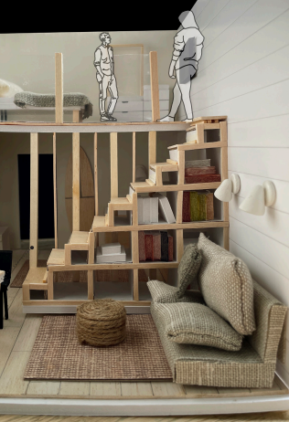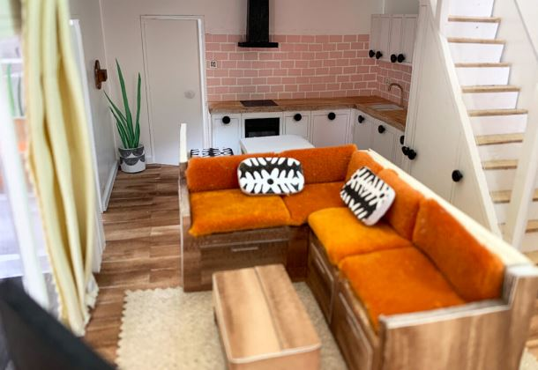

Fig. 2. Students Examples, Examples of scale models

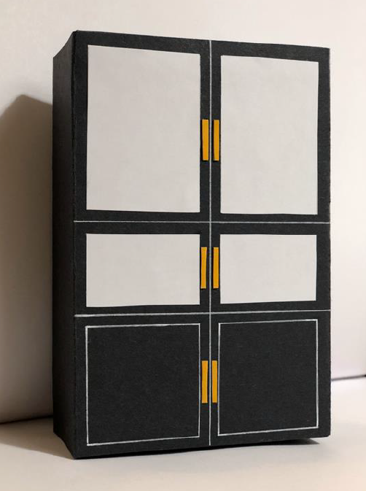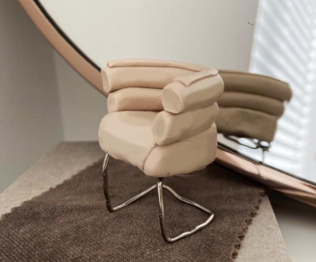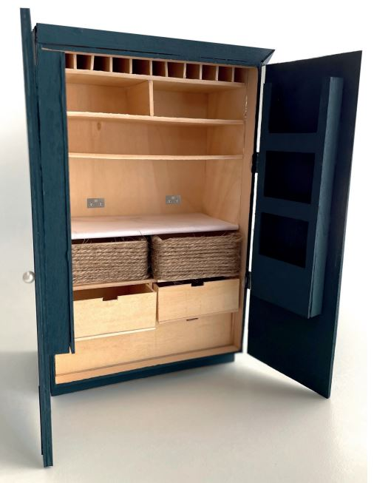

Fig 3. Examples of scale models

### Materials

While there are a number of different materials you can use for your model, such as cardboard, timber or polystyrene, models for interior design are best made from white foam board (also called Kappa board). This type of board consists of two sheets of thin card with a layer of foam in the middle. It is light and easy to cut and sturdy enough to use for walls etc. An alternative to Kappa board is a plain white mounting board.

For the base of the model, you can either use a material that does not bend, e.g. a thicker white board, or a piece of medium-density fibreboard (MDF) or plywood cut to size. Or again, for consistency, use a foam board. You can use all types of material for your model, from cardboard to balsa wood, or foam board, but also paper, card, metals, plastics, modelling dough etc.

Examples of materials needed to build a 3D scale model:

* Paper for planning, e.g. graph paper
* Measuring tape (if the model is based on an actual room)
* Cardboard, foam board, or balsa wood for the model structure
* Cutting tools (e.g. hobby knife, scissors)
* Ruler and T-square
* Glue and adhesive tape
* Paints and markers for details
* Miniature furniture and decorations (optional)

### Steps to Create the Model

#### Measure the Room

Use a measuring tape to take precise measurements of the actual room or note the dimensions of a given or hypothetical space. Record the dimensions of the walls, windows, doors, and any built-in furniture.

#### Plan the Model

Choose a scale for your model. Common scales are 1:20 (1 unit on the model equals 20 units in real life) or 1:50. Using your recorded dimensions, draw the room layout (graph paper works well) and include all features such as doors, windows, and any built-in elements.

#### Prepare the Materials

Transfer the dimensions from your paper plan to the cardboard or foam board, or whichever appropriate material you decide on. Cut out the walls, floor, and ceiling pieces according to your measurements and scale.

#### Assemble the Structure

Begin by assembling the walls. Use glue or tape to join the pieces together, ensuring the angles are accurate and the structure is stable. Attach the floor piece to the walls. If you want a complete enclosed model, add the ceiling piece, but this is optional as you may want to keep the model open for better viewing.

#### Add Details

Cut out windows and doors from the walls. You can use clear plastic sheets for windows or keep it open. Paint or decorate the walls, floor, and ceiling to match the intended colour palette of your room.

#### Furnish the Model

Create or purchase miniature furniture and decorations that fit the scale of your model. For this assignment, you can keep furniture and other fixtures and accessories simple, i.e. use geometric shapes that represent these pieces. There is no need for excessive/realistic detail for the assignment. Arrange the forms that represent furniture in the model to replicate the actual room layout, or design your own layout.

#### Finishing Touches

Add any final details such as light fixtures, rugs, or artwork. Ensure everything is securely attached and the model is stable.

### Tips:

* Precision is key: Accurate measurements and cuts will make your model more realistic.
* Use templates: Create templates for windows, doors, and other repeated elements to ensure uniformity.
* Take your time: Building a detailed model can be time-consuming, so work patiently and methodically.
* Experiment with materials: Different materials can add texture and realism to your model. Experiment to see what works best for your project.

### Additional support resources

* YouTube tutorials
  + [How to Create a 3-D Interior Model](https://www.youtube.com/watch?v=X5MOaW_JkpU)
  + [DIY Miniature Modern Apartment Model](https://www.youtube.com/watch?v=_Z-Q_OWyp9s)
  + [Simple Building Design 36x30 MODEL MAKING](https://www.youtube.com/watch?v=j5D1dCrGFW4)

Scaled models remain a vital tool in the practice of interior design. While digital tools offer increasingly sophisticated visualisation options, the tangible nature of a physical model provides unique benefits. It bridges the gap between concept and reality, facilitating better communication, problem-solving, and spatial understanding. By offering a tangible representation of the design, scaled models empower both designers and clients to make informed decisions, ultimately leading to more successful and satisfying interior spaces.